**Distributed Logging with Zipkin & Sleuth**

We will implement distributed logging so that for 1 particular request we can get 1 trace id which will remain same for that complete request.

For each Trace id we will get many span id which will be different as we traverse through different microservice.

With this mechanism we can track 1 request how it travelled through different microservices to complete that request with the help of 1 traceid but multiple spanid, we can track where was failures and successes during our request lifecycle, this is called distributed logging.

1. We will create Zipkin server
2. We will Zipkin client and Slueth in all our microservices

Create Zipkin Server, visit <https://zipkin.io/>

Go to quickstart and download latest jar and run it, java -jar jarname.jar

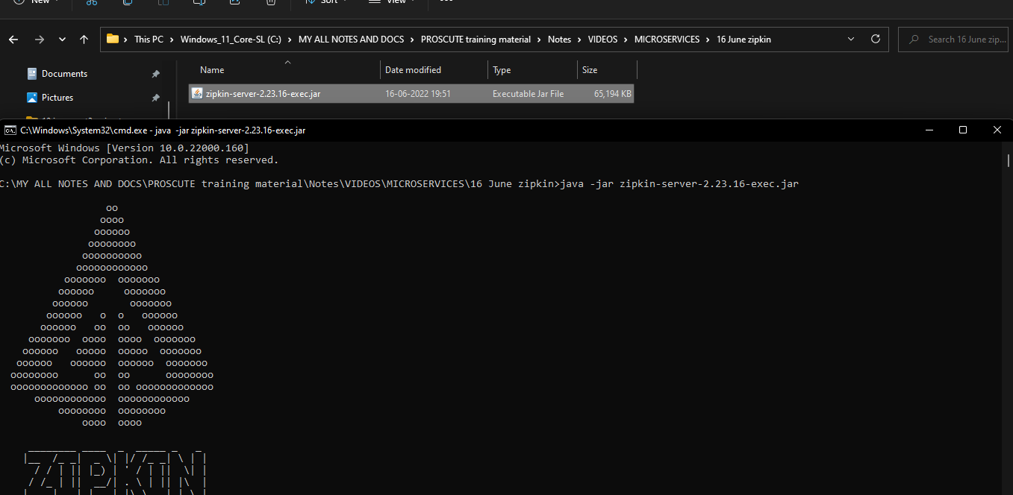

Open the zipkin server url on browser

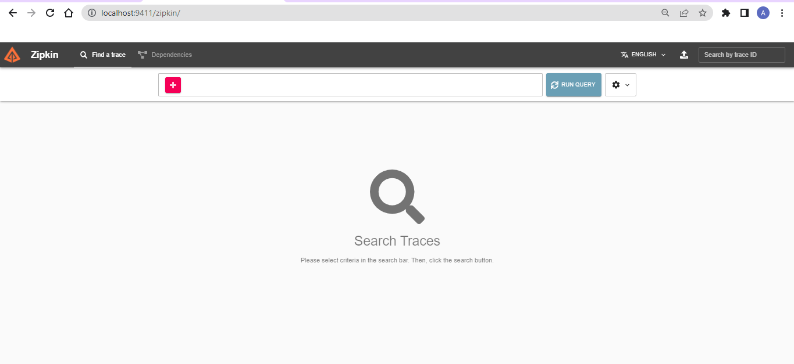

Add below dependency to client like Book & Order service and more if they have logging enabled

<dependency>

<groupId>org.springframework.cloud</groupId>

<artifactId>spring-cloud-starter-sleuth</artifactId>

</dependency>

<dependency>

<groupId>org.springframework.cloud</groupId>

<artifactId>spring-cloud-starter-zipkin</artifactId>

<version>2.2.8.RELEASE</version>

</dependency>

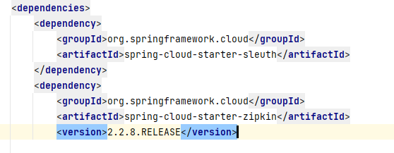

Add the zipkin server base url to microservices, in application.yml

spring:

application:

name: BOOK-SERVICE

zipkin:

base-url: <http://127.0.0.1:9411/>

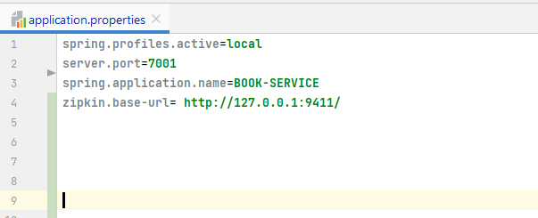

Start Order & Book service

Hit the Get books, Order Books, Get Order services via API gateway

In the console of Book & Order service we will see 4 infor from Zipkin & Sleuth [service name, trace-it, span-id, export-flag]

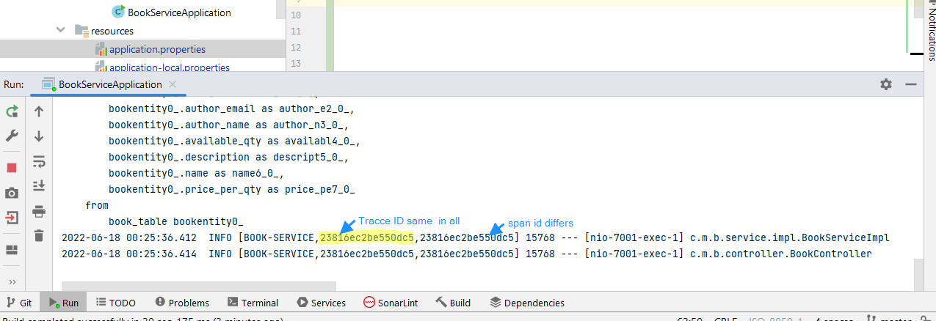

Trace-id will be same for both Service for 1 particular request but Span-id will differ

Go to zipkin server on browser and refresh and click on plus and choose serviceName and run query, here we can visualize logs for 1 request

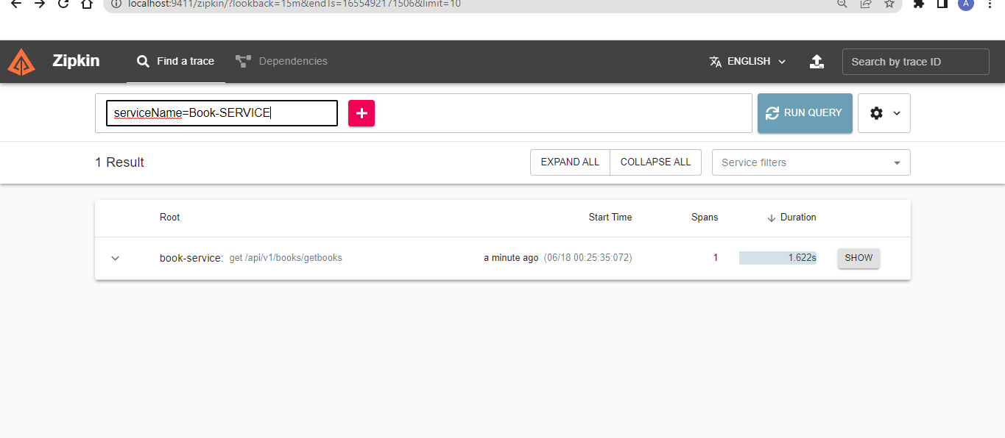

Click on dependencies tab to see how microservices are dependent